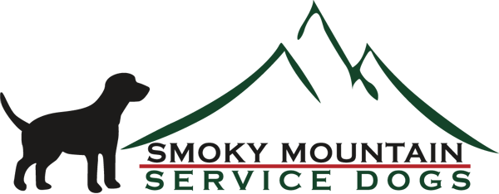

Organization: Smoky Mountain Service Dogs

SMSD Mission - To enhance the physical and psychological quality of life for wounded Veterans by providing highly trained/custom trained mobility assistance service dogs. (At no cost to the Veteran)

Contact: Mike Kitchens
Smoky Mountain Service Dogs
8380 Fairview Road
Lenoir City, TN 37772

Contact - mike.k@smokymountainservicedogs.org
Website: https://www.smokymountainservicedogs.org/
Facebook: https://www.facebook.com/smokymountainservicedogs
Instagram: https://www.instagram.com/smokymountainservicedogs/
TikTok: https://www.tiktok.com/@smokymountainservicedogs?lang=en
YouTube:https://www.youtube.com/@SmokyMountainServiceDogs
Video: Smoky Mountain Service Dogs "Tribute to Our Military" - YouTube

Other:
For Volunteer Opportunities contact our Volunteer Coordinator: smsdvolunteer@smokymountainservicedogs.org
For Veteran questions contact Suzy: suzy.k@smokymountainservicedogs.org
Fundraising or Civic Group Presentations, contact Mike: mike.k@smokymountainservicedogs.org
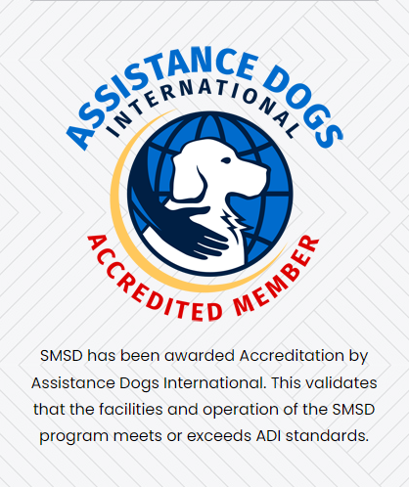

For the video of Hooligan and Winston - The two black labs were Canine Ambassador "Hooligan" and Junior Canine Ambassador "Winston". Hooligan was named by the parents of US Army Specialist John Hargraeves who sacrificed his life while serving in Afghanistan. His parents named "Hooligan" after their son's platoon in Afghanistan know as the Hooligans, they took great pride in the name.

